**Al-Hussein Technical University of Jordan**

**Upskilling Program**

**Full-Stack development using PHP**



**HTU-Point of Sale**

**By**

**Abdulrahman Husam Hasan**

**(JANUARY 2023)**

**Table of Contents**

**List of Figures..………………………………………………..……………….….....…..3**

**Abstract…...………………………………………………………….........……..……......4**

**List of Abbreviations and Terminologies .…………………….…………..……...……5**

**1: Introduction…………………………………………………………………………...6**

1.1: Problem Description**………………………………………………………………………….7**

1.2: Project Objectives**…………………………………………………………………………….7**

**2: Analysis phase…………………………………………………………………………………7**

2.1: Functional Requirements Analysis**…………………………………………………………...8**

**3: Design Phase…………………………………………………………………………………...9**

3.1: Functional Needs Analysis flow chart**……………………………...………………………...9**

3.2: UML Diagrams**…………………………………………………………………………...…10**

3.2.1: Use-case Diagram**…………………………………………………………………………10**

3.2.2: System Components Overview**……………………………………………………………11**

**4. Conclusion……………………………………………………………………………………12**

**References……………………………………………………………………………….13**

**List of Figures**

3.1: Functional needs analysis……………………………………………………………………9

3.2: Use Case-Diagram………………………………………………………………………….10

3.3: System Components Overview……………………………………………………………..11

**Abstract**

Sales is the activity of trade in goods and services to customer. Process sales and service transactions should be done properly, old systems (Cash register system) have many disadvantages like errors in recording, the calculation is less precise, and the speed in service is low. And since we are in technology era (time) we have to find a modern, economic, effective, accurate, fast, convenient solution, Which is the -POS web application- my project today.

**List of abbreviations and terminologies**

* **UML:** The Unified Modeling Language is a general-purpose, developmental, modeling language in the field of software engineering that is intended to provide a standard way to visualize the design of a system.
* **Database:** is an organized collection of data, generally stored and accessed electronically from a computer system. Where databases are more complex, they are often developed using formal design and modeling techniques.
* **Use-case Diagram:** is a graphical depiction of a user's possible interactions with a system. A use case diagram shows various use cases and different types of users the system has and will often be accompanied by other types of diagrams as well.
* **Analysis**: is the process of breaking a complex topic or substance into smaller parts to gain a better understanding of it.
* **Stakeholder**: is a party that has an interest in a company and can either affect or be affected by the business.
* **Information Systems**: the information system is an organized way to collect, add, process, and store the data so that the group / organization can achieve its objectives, Information Systems is a set of interrelated components that collect, process, store, and distribute information to assist in decision-making and business management .
* **Sales**: is comprised of the sale of goods or services, either in cash or in the form of credits. Sales is the activity of trade in goods and services to customer.
* **Point of Sales (POS):** Point of Sales or simply called POS, it can be defined as software that records sales transactions. Before the POS system is developed, many people use a cash register, or even manually, to manage their business. But the teller machine function itself is no longer sufficient, so that POS has been developed.
* **PHP**: can be used to create dynamic web pages thanks to one of its advantages: the ability to connect to a variety of software database management system or DBMS (Database Management System).
* **MySQL:** is a database management system that uses SQL (Structured Query Language) as a common language used to add access and process data in a database.

1. **Introduction**

Over time, technology is growing so fast. especially, the technology in trading or selling. Businesses are always looking for faster, more efficient ways of doing things. For this reason, many of them have ditched their cash registers and made the transition to point of sale (POS) systems.

In a nutshell, a cash register is a machine that records sales transactions, gives change and holds money. A POS system is a computerized system that handles financial transactions, tracks inventory, and records many types of business data.

The biggest difference between a cash register and a POS system is efficiency and communication. When a transaction is processed at a retail store or any other type of business, the POS system not only records the transaction, it automatically does real-time tracking of everything related to what the customer purchased. For instance, if a customer buys a purse, the POS cash register will record everything about the transaction including the tax information. Once the information is captured, it is stored in a database where authorized company representative can access it when they need to.

In addition, cash register systems may face a lot of errors in recording, the calculation is less precise, and the speed in service is often low. The use of technology (POS system) can be a solution in the recording and processing of transactions so it is done by a computerized system, as it will speed up the transaction process and gives accurate results so that a more effective and efficient. The computerized transaction provides convenience in work and a definitive result for the buyer and customer.

**1.1 Problem Description**

HTU established a store inside King Abdullah Business Park. The IMU in HTU recruited you to build a Point of Sale (POS) web application to handle the store sales transactions and stock. There are many employees with different roles that will work on the POS. The admin of the POS system wants to see quick information of the total sales and transactions in addition to the stock of each item.

So, here comes the role of our web application HTU-Point of Sale.

**1.2 Project Objectives**

* Help business owners (administrators) make business decisions by keep them able to access the system even once they are at home or traveling. No matter where you are, you’ll always have the information you need to. *And we achieved that by deploy the system (Project) on a server.*
* Make a good functional, reliable, and enjoyable to use user interface.
* Provide Stocks Processes (Add/delete/update) and selling functionalities in a simple, organized, and Secure steps.

**2. Analysis phase:**

Analysis: is the process of breaking a complex topic or substance into smaller parts to gain a better understanding of it. and here we made some process to break the problems and get better understand to start implementation.

**2.1** **Functional Requirements Analysis**

|  |  |
| --- | --- |
| Functional Requirement | Responsible |
| Procurement Manager | * Adding incoming goods * Renewed data items * Deleting data items * Show all stocks (items) * Edit his profile info |
| Seller (Cashier) | * Adding a sales transaction * Check goods and their prices * Show today transactions and ability to edit or remove any transaction * Edit his profile info |
| Accountant | * Show all users transactions * Create sales reports * Ability to edit any transaction * Edit his profile info |
| Admin | * Can access every thing above plus * Adding users * Deleting user * Updating user info * Show users * Edit his profile info |

**3. Design phase**

**3.1 Functional Needs Analysis flow chart**

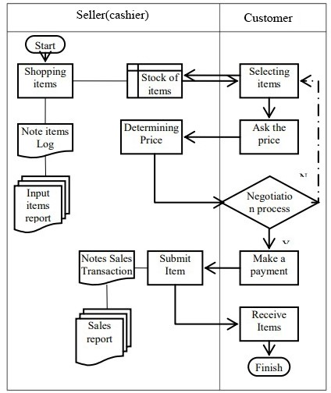

Figure 3.1: functional needs analysis.

**3.2 UML Diagrams**

**3.2.1 Use-case Diagram**

This is the use case diagram of our project; It shows the available functions that every user can do and what functionalities the program has in general. (Shown in fig 3.2).

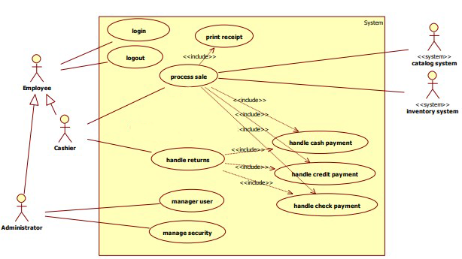

Figure 3.2: Use Case-Diagram

**3.2.2** **System Components Overview**

The image below contains a high-level overview of the component hierarchy within the web application.

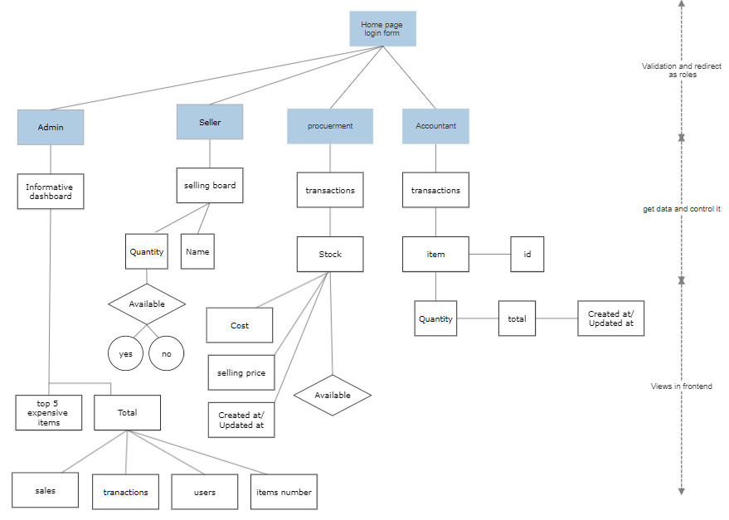

Figure 3.3: System Components Overview

**4. Conclusion**

Point of sale systems has many beneficial features that allow you to stay in depth eye on sales, profits, and expenses like Cost of products Sold. POS reports give you in real-time, and formatted with easy-to-read information. With our POS web application, you'll be able to access reports even once you are at home or traveling. No matter where you are, you’ll always have the information you need to make data-driven business decisions. Your POS system will also allow you to monitor Key Performance Indicators such as average customer sales, stock turnover, and sell-through rate. This visibility into your business performance will assist you identify prosperous areas of your business and others that will need improvement. Either way, this insight will assist you in making the required adjustments to assist you maintain profitability and competitiveness. A point-of-sale system helps make more efficient the accounting process. Old-fashioned cash registers force accountants to sort through many receipts, but with a POS system, you'll print reports and, in many cases, import data directly together with your accounting software.

The design of the system done by using HTML5, CSS3, Bootstrap, JS and for back-end design I used MySQL database, programming language used are PHP and software XAMPP. The process of creating a software program code using Visual Code.

From this web-application, we produced a web-based system that is used to process sales transactions and processing data easier, safer, effective, and efficient.

**References**

<https://bepoz.com/blog/difference-cash-registers-pos-systems/>

<https://www.truemerchant.com/food-andbeverage-pos/>

<https://www.linkedin.com/pulse/top-7-ways-increase-your-food-beverage-revenues-russell-blakeborough>

<https://www.oracle.com/th/industries/hospitality/products/simphony-point-of-sale-hotel.html>

<https://www.embedcard.com/resources/blog/food-beverage-pos-system-benefits>